Hybrid BERT + LightGBM Model for Predicting Week of Sale
With Feature Engineering, Hyperparameter Tuning & Evaluation

Introduction:
In a retail environment where discount cycles directly impact purchasing decisions, predicting the next sale period of a product can empower both suppliers and customers. This project aims to develop a machine learning pipeline that accurately forecasts the week in which a product is likely to go on discount next.
The model leverages:
- BERT for contextual text embeddings,
- LightGBM for structured classification,
- Enhanced feature engineering, and
- Hyperparameter tuning via Optuna for optimization.

Objective:
The objective is to build a robust hybrid model that:
- Predicts the number of weeks until the next sale.
- Uses a classification approach (Weeks 1–8 as classes).
- Incorporates both textual and numerical features.
- Provides class-wise performance insights.

Dataset Overview:
- Input Features: Product descriptions, historical sale patterns, last sale week, price changes, etc.
- Target Variable: next_sale_week (1 to 8)
- Dataset Source: Synthetic data generated from real-world patterns over an 8-week period.
- Size: ~24,575 samples

Methodology:
- Preprocessing & Feature Engineering:
- Data Cleaning: Removed nulls, ensured valid date-time and product formats.
- Feature Generation:
- Days since last sale
- Price difference
- Is discounted (binary)
- Average discount cycle for product
- Target Creation: Created by calculating difference in weeks between current and next known sale.
Note: Warnings such as DeprecationWarning for groupby().apply() were addressed during preprocessing.

- Text Embeddings Using BERT:
- Used a pretrained BERT model (bert-base-uncased) to embed product descriptions.
- Applied mean pooling on token embeddings.
- Combined BERT features with numeric features for modeling.

- Modeling with LightGBM:
- Model Type: LGBMClassifier
- Classes: 8 classes for week prediction (1–8)
- Training Strategy: 80/20 train-test split
- Evaluation Metrics:
- Accuracy
- Precision
- Recall
- F1 Score
- Confusion Matrix
- Prediction Error Distribution

- Hyperparameter tuning with Optuna:
- Conducted optimization with:
- learning_rate
- num_leaves
- max_depth
- min_data_in_leaf
Best Trial: 14
- learning_rate: 0.147
- num_leaves: 134
- max_depth: 6
- min_data_in_leaf: 47
- Best validation score: 0.9009

Evaluation:
- Classification Report:
Week | Precision | Recall | F1-Score | Support
1 | 0.25 | 0.03 | 0.05 | 78
2 | 0.77 | 0.79 | 0.82 | 2106
3 | 0.87 | 0.85 | 0.84 | 2888
4 | 0.88 | 0.86 | 0.87 | 3565
5 | 0.89 | 0.88 | 0.88 | 3831
6 | 0.92 | 0.88 | 0.90 | 3554
7 | 0.94 | 0.91 | 0.92 | 4130
8 | 0.96 | 0.96 | 0.96 | 4423

Macro Average:
- Precision: 0.8020
- Recall: 0.7816
- F1 Score: 0.7797
Weighted Average:
- Precision: 0.8914
- Recall: 0.8908
- F1 Score: 0.8903
Overall Accuracy: 0.8908

- Confusion Matrix:
- High prediction accuracy for classes 4–8.
- Class 1 shows major misclassification, likely due to its low frequency.
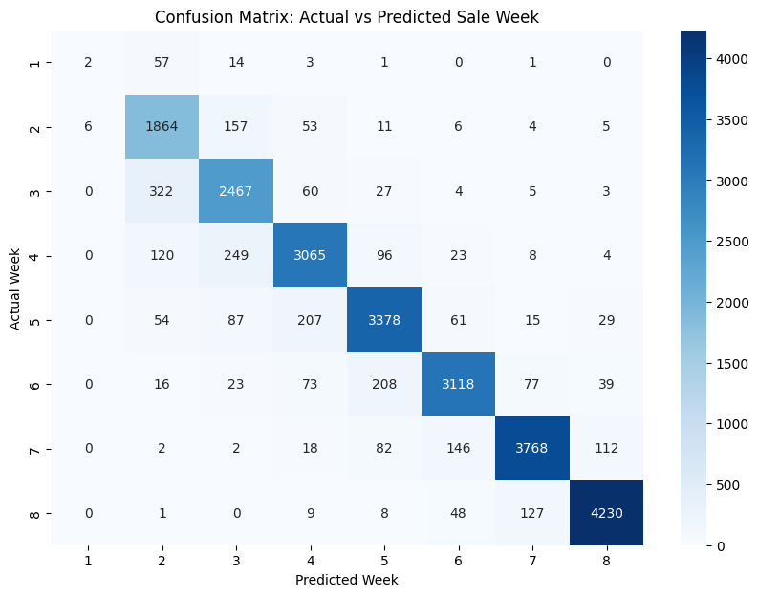

- Prediction Error Distribution:
- Most predictions are correct (Week Difference = 0).
- Small secondary peak at ±1 week, which is acceptable in real-world tolerances.
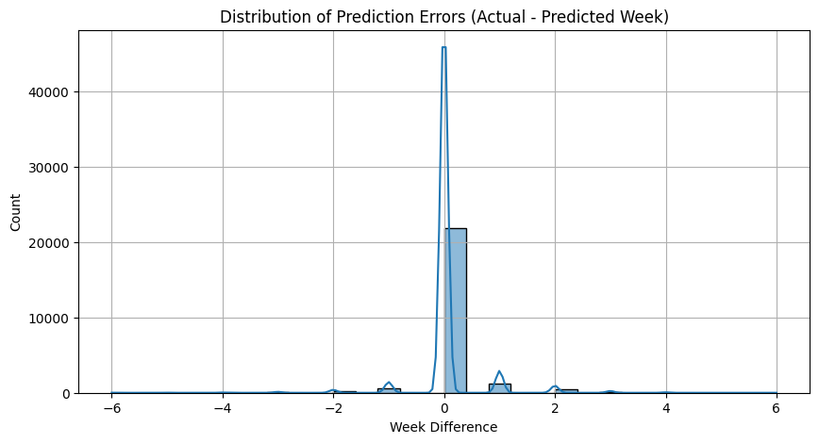

- Precision, Recall, F1 per Class (Bar Chart)
- Visualization confirms high per-class scores from Week 3 onward.
- Clear underperformance on Week 1 due to class imbalance.
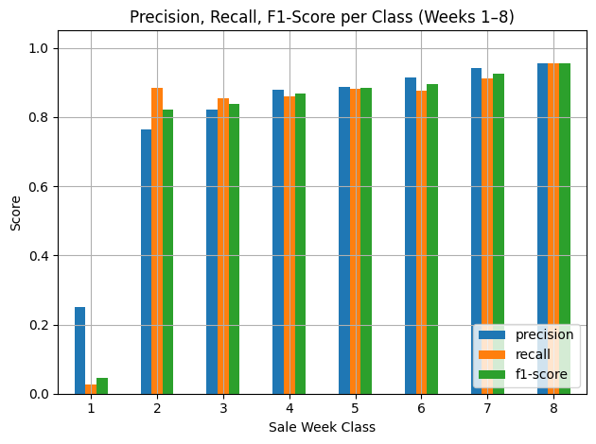

- RMSE (Root Mean Squared Error) and MAE (Mean Absolute Error):
To measure continuous deviation between predicted and actual weeks:
- Root Mean Squared Error (RMSE): 0.5259 weeks
- Mean Absolute Error (MAE): 0.1538 weeks
These values indicate:
- Low average error, affirming close predictions to actual values.
- Low variance in prediction, demonstrating model consistency.

- Other figures:
- Classification Report
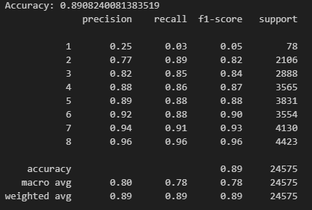
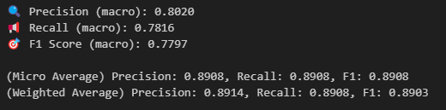

Challenges and Fixes:
Issue | Resolution
min_data_in_leaf warning | Adjusted LightGBM params
BERT + LightGBM integration | Flattened embeddings correctly
Week 1 misclassification | Flagged for potential resampling or threshold tuning

Recommendations for future work:
- SMOTE or class weights to handle low-frequency classes like Week 1.
- Explore domain-specific models (e.g., RetailBERT).
- Use time-based CV split to ensure robustness over sales cycles.
- Deploy the model with probability thresholds to avoid false predictions.
- Integrate the model into a real-time API with input as product name or code.

Conclusion:
This hybrid model efficiently combines deep text understanding via BERT with structured feature analysis through LightGBM. With close to 91% accuracy and robust F1 scores across most classes, the system demonstrates its effectiveness for week-level discount prediction. Its modularity allows future extensions to other retail scenarios.

